**Big Data: Image Analytics-Classification**

**Image classification** analyzes the numerical properties of various **image** features and organizes data into categories. **Classification** algorithms typically employ two phases of processing: training and testing.

**Steps for Image analytics classification:**

1. **Import Images:** The first thing to do is to import the image via the **Import Images** widget. You can think this widget as the **File**widget for image. However, **Import Images** widget accepts a directory instead of a file.

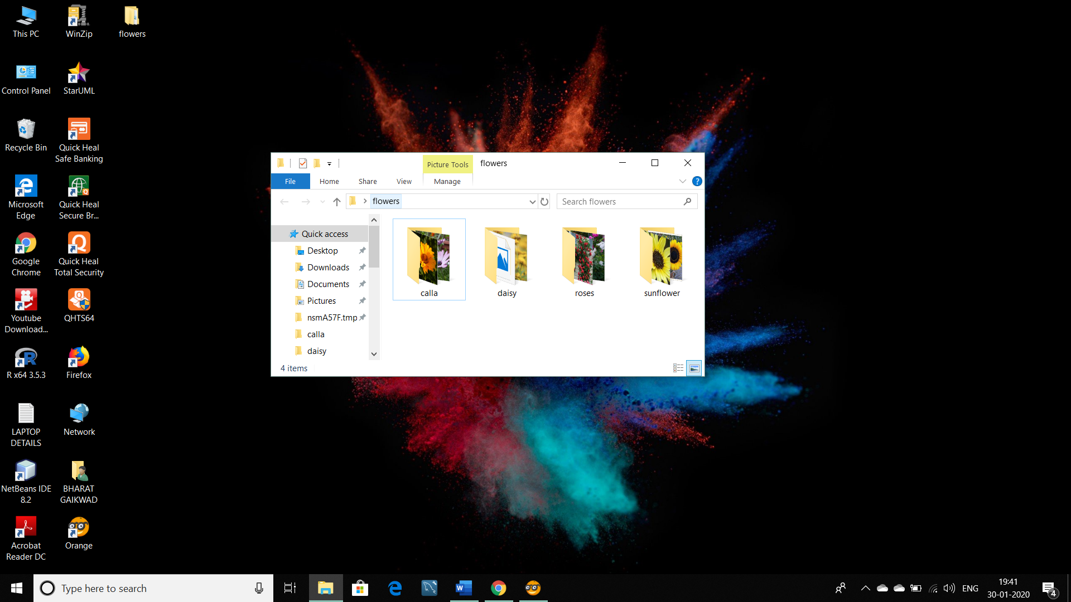

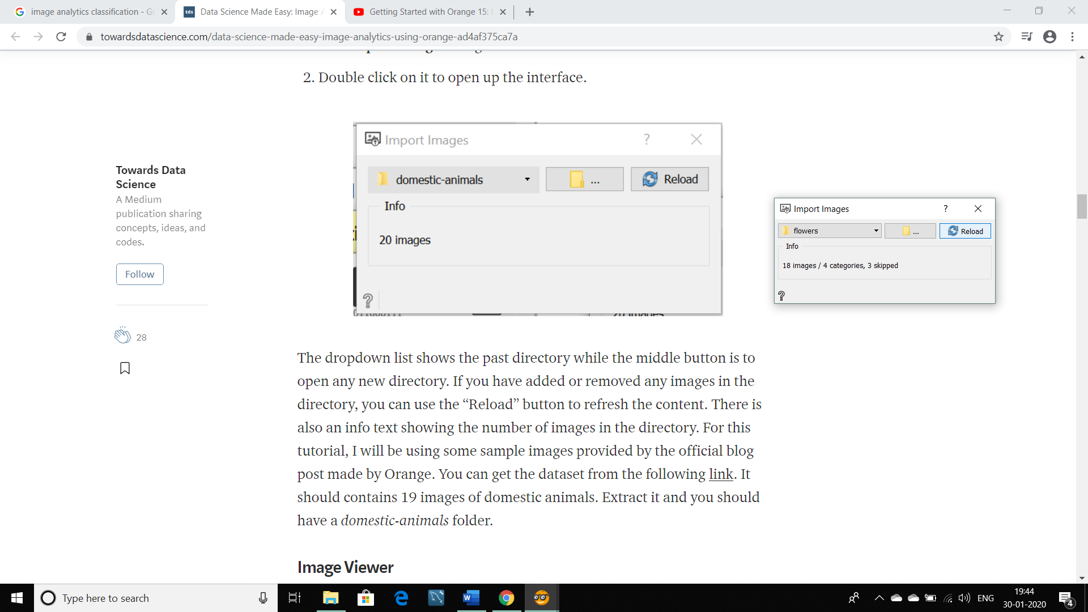

## Image Viewer: Next, we will be relying on the ****Image Viewer**** widget to check the content of the directory. This widget will display all of the loaded images.

## Connect Image viewer to import images

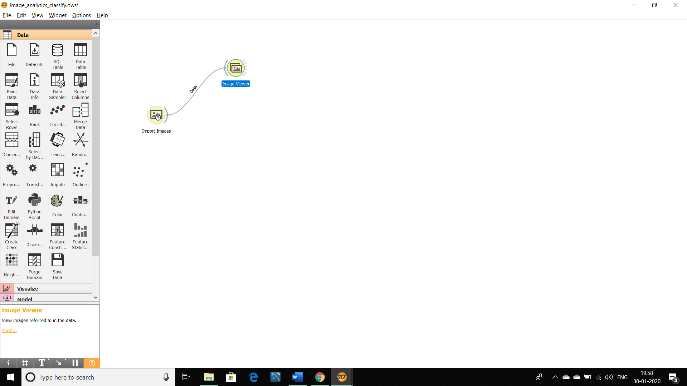

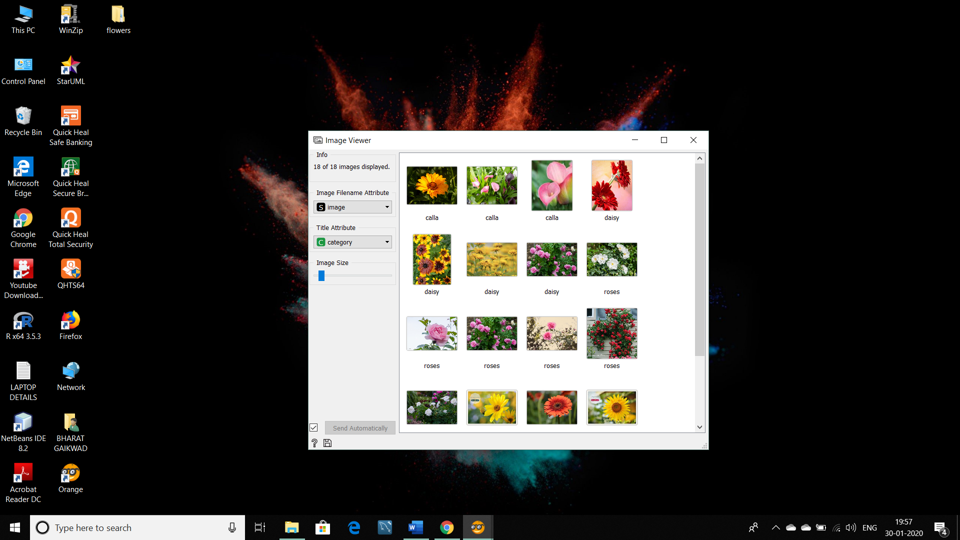

1. **Image Embedding:** Classification and regressions tasks requires data in the form of numbers and there isn’t a good way to perform such tasks with images unless we represent it in the form of numbers.

* This is where **Image Embedding** widget works by converting it to a vector of numbers. **Image Embedding** widget reads images and uploads them to a remote server or evaluate them locally.

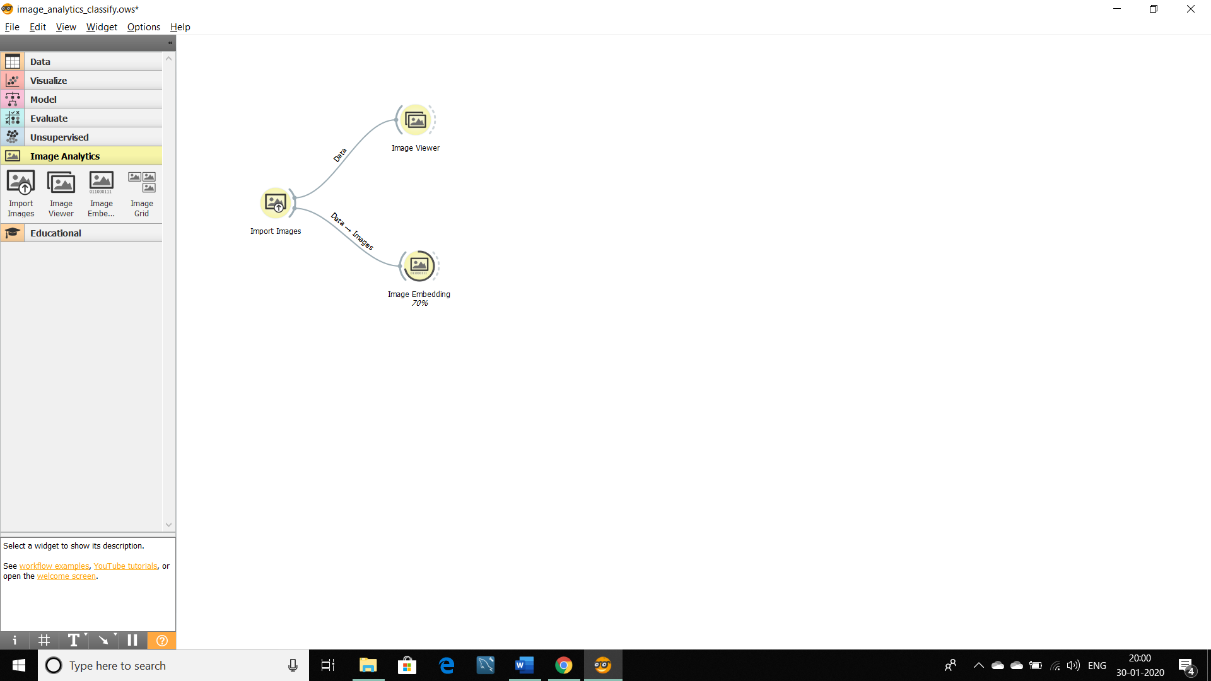

1. **Data Table:** Data Table widget receives one or more data sets for all images with their features and presents them in a spreadsheet format.

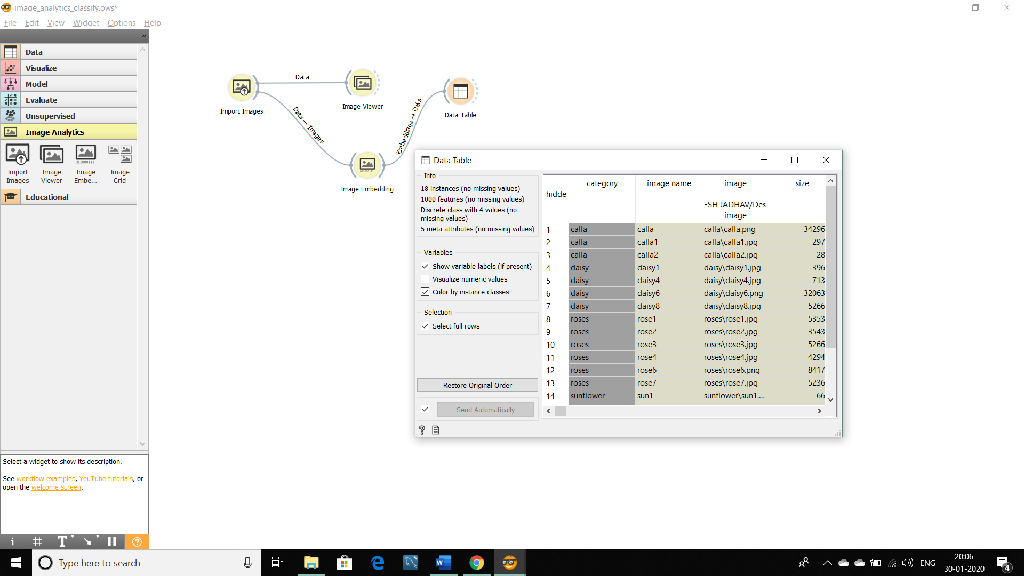

1. **Test and Score:** For cross validation accuracy estimation, we use test and score widgets. But for that, we have to connect test and score to logistic Regression.

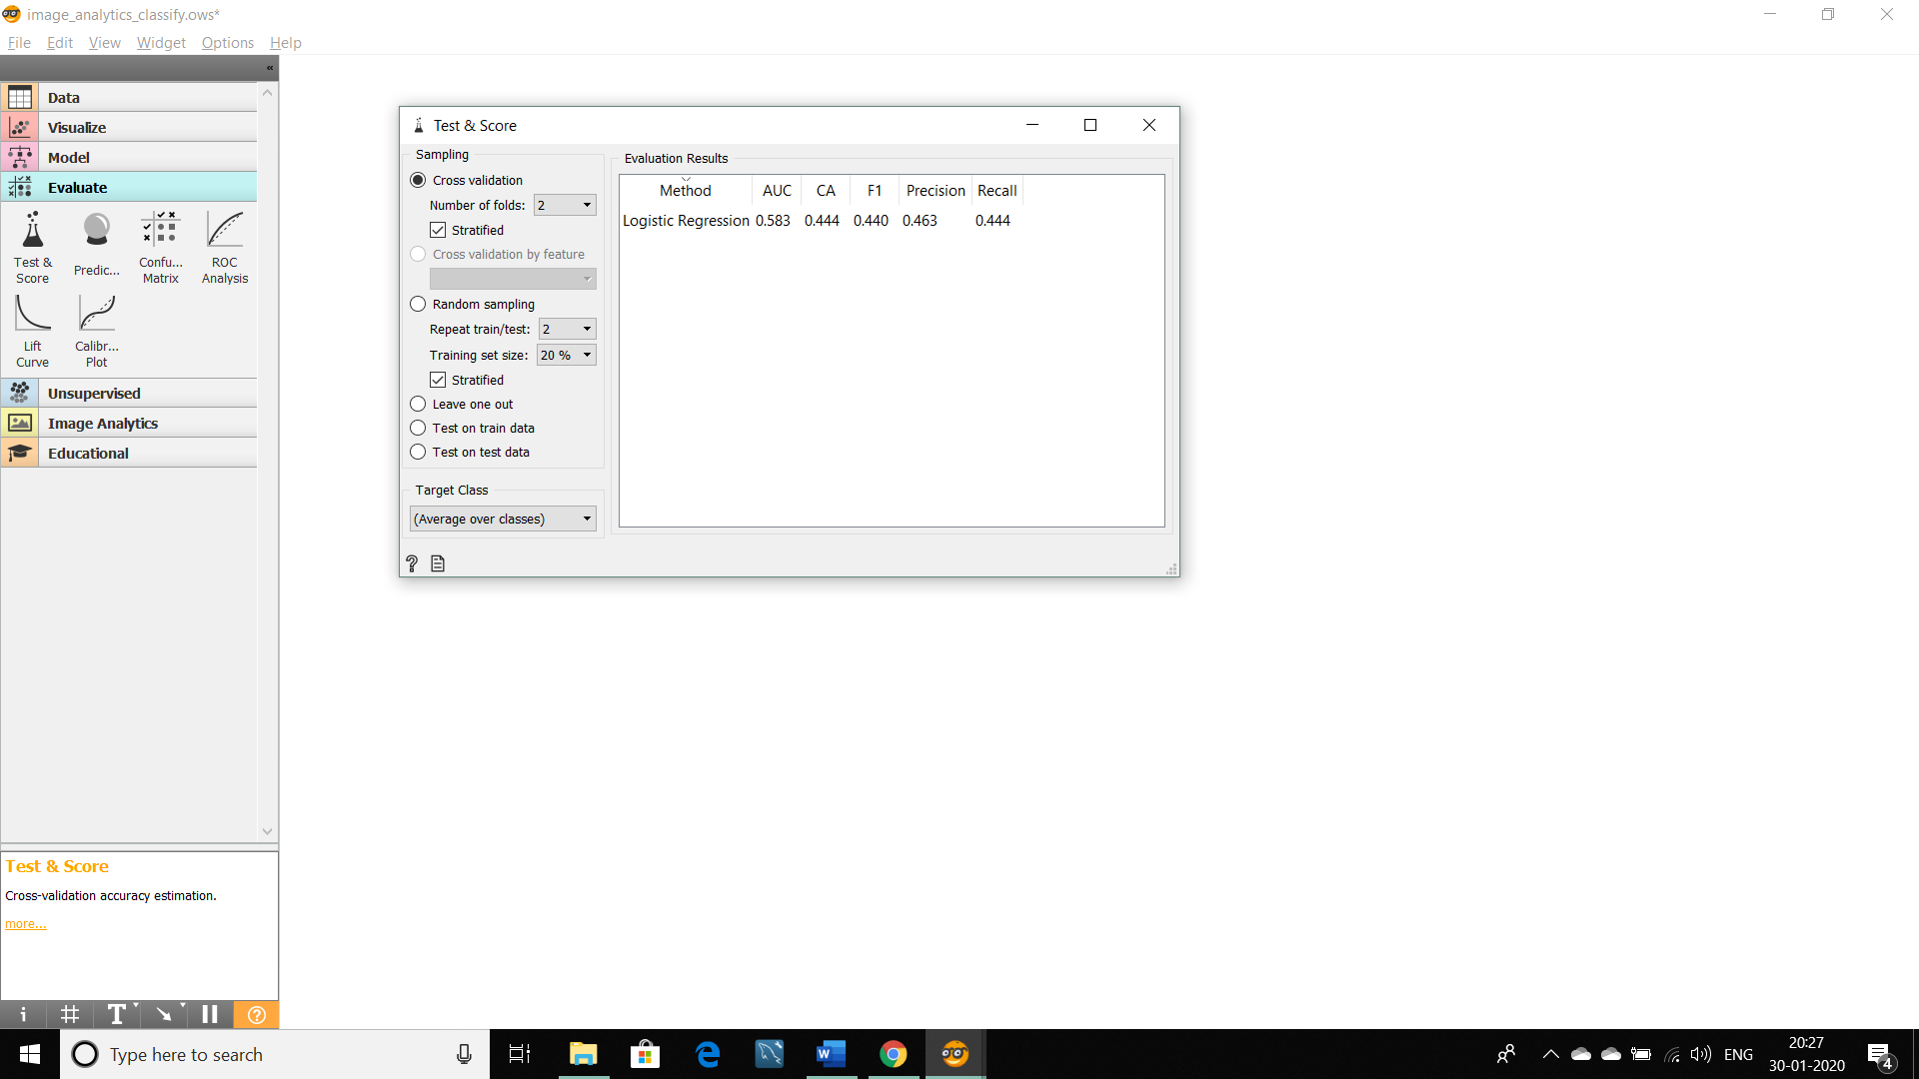

1. **Logistic Regression:** The widget is used just as any other widget for inducing a classifier. **Logistic Regression** learns a [Logistic Regression](https://en.wikipedia.org/wiki/Logistic_regression) model from the data. It only works for classification tasks.

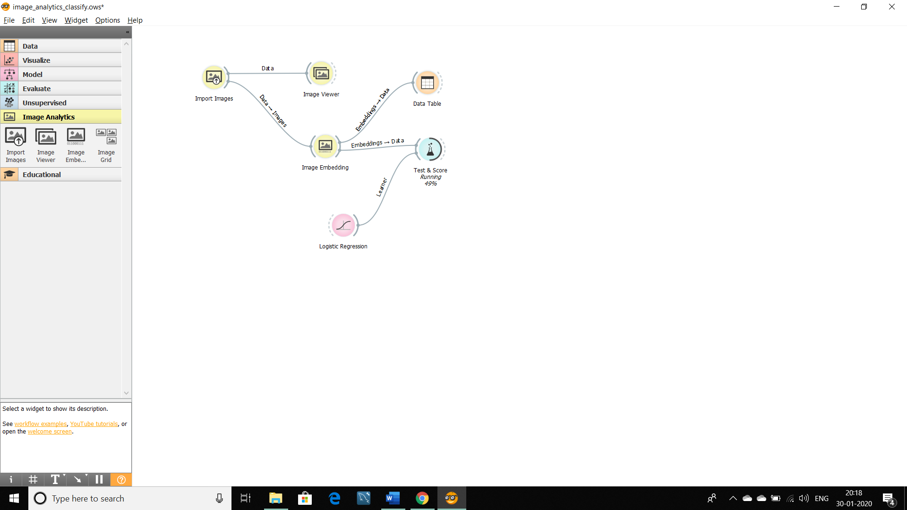

1. **Confusion Matrix:** The [Confusion Matrix](https://en.wikipedia.org/wiki/Confusion_matrix) gives the number/proportion of instances between the predicted and actual class.

From the table, we have to select one cell from misclassified to see the specification.

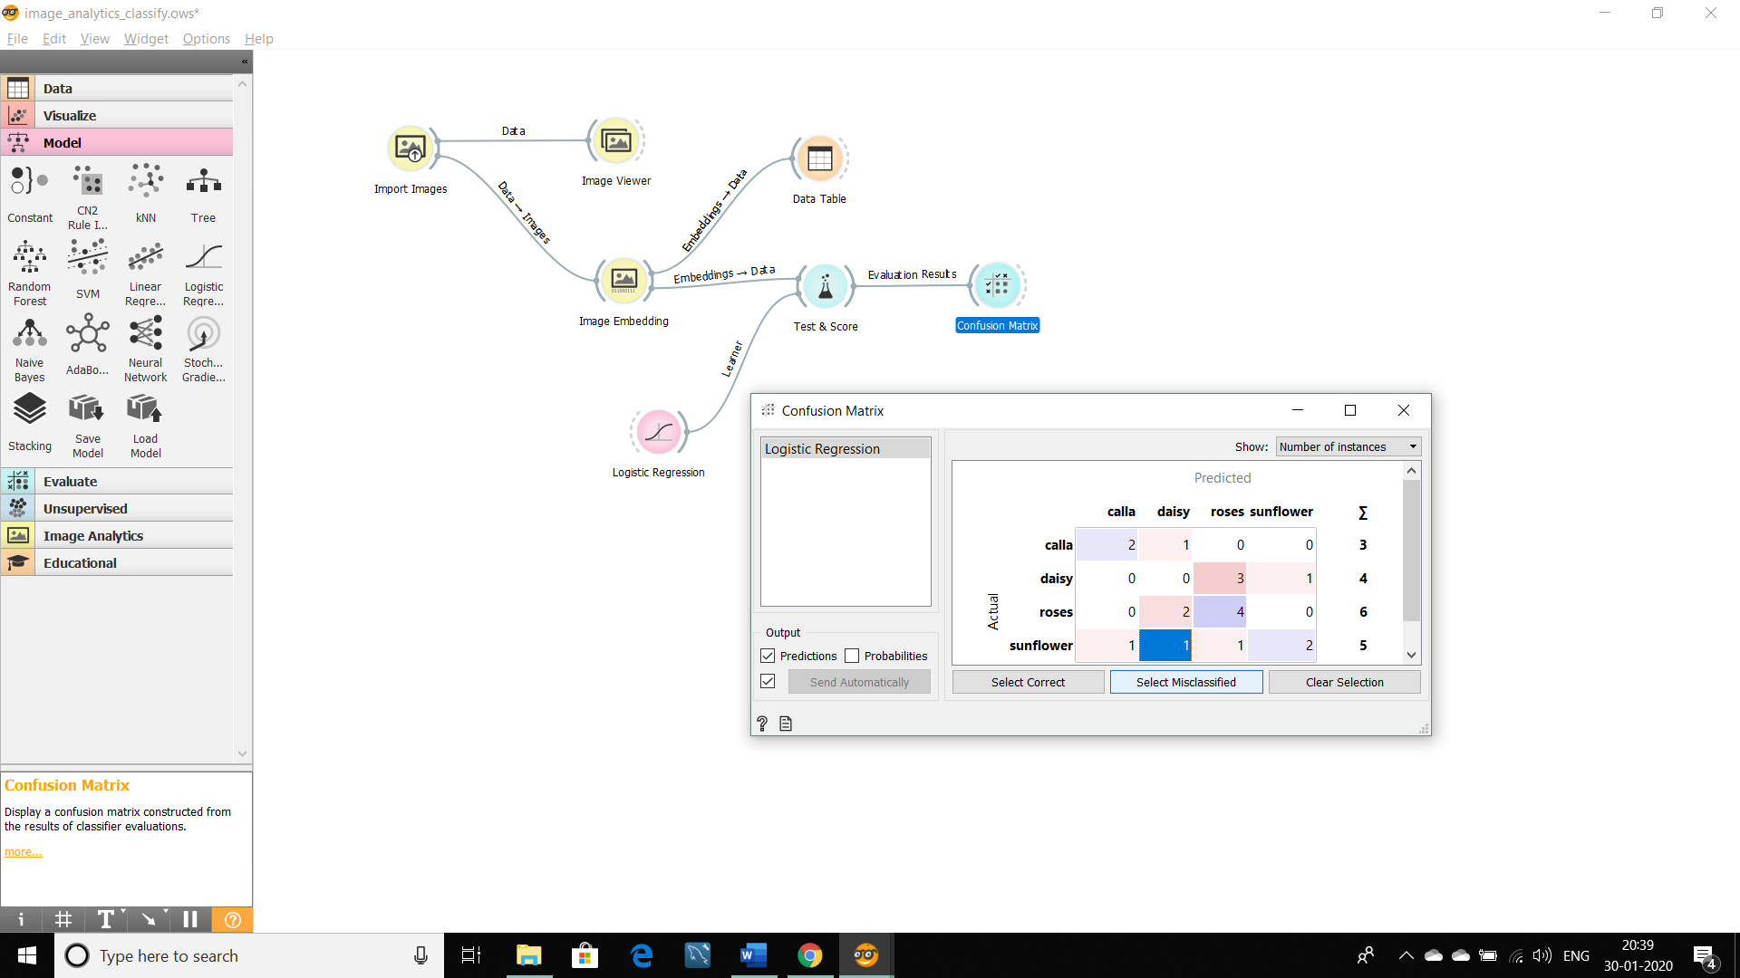

1. **Image Viewer:** After selecting the cell, we can see the specification between actual and predicted classes of images in an image viewer.

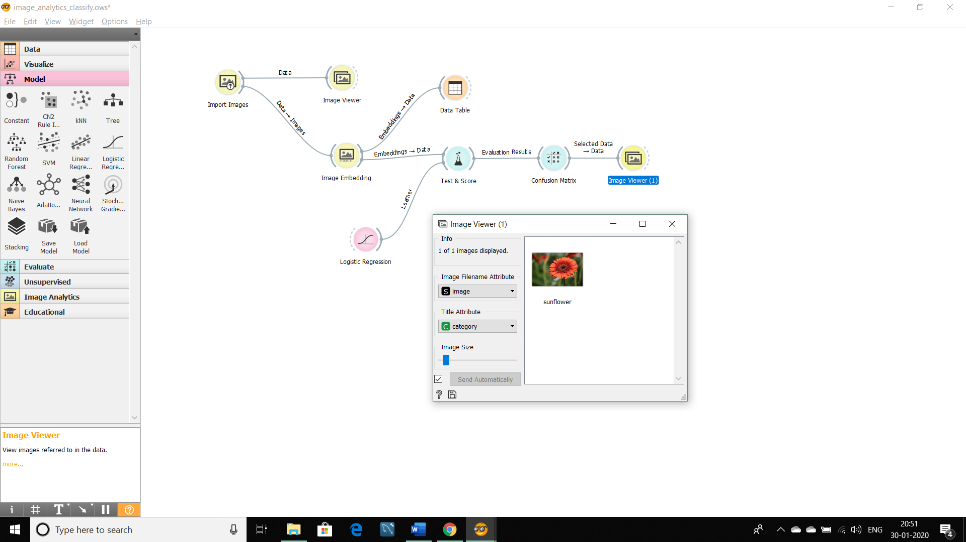

**Image Analytics-Classification:**

